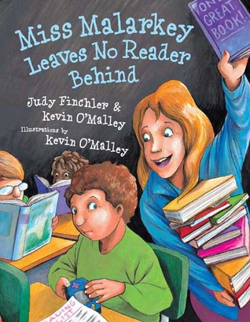

**Who**: Attention all Kindergarten and First Grade students

**What**: Kevin O’Malley Writing/Drawing Activity

Amazing author and illustrator, Kevin O’Malley, will be visiting our school on March 17, 2014. To celebrate his arrival, we invite you to complete an activity based on his story, Miss Malarkey Leaves No Reader Behind. In this book, Principal Wiggins has promised to dye his hair purple and sleep on the school roof if the students read 1,000 books during the school year! Miss Malarkey sets out to find the right book for each student in the school, in hopes that every boy and girl will LOVE to read.

**Activity:** Imagine that the students in Liberty Corner School read 5000 books this year! What would you like to see our principal, assistant principal, or teachers do to celebrate this achievement? Please draw a picture and/or write about your ideas.

**When**: Entries must be handed in by Wednesday, March 12, 2014.

**Where**: Entries must be submitted to Mr. Mullarkey in the library.

**Why**: To celebrate the arrival of Kevin O’Malley and earn the chance to share dessert with him! All students who complete the activity will be entered into a drawing, and several students will be selected randomly to have dessert with Mr. O’Malley.

Please be sure to include your name and grade!